Project Design Phase-II
Data Flow Diagram & User Stories
Date | 13 February 2026
Team ID | InfiniteLoops
Project Name | Exploratory Analysis of Rainfall Data in India for Agriculture
Maximum Marks | 4 Marks

Data Flow Diagram (DFD - Level 0)
A Level-0 DFD illustrates how data flows between the user, web application, preprocessing layer, ML model, and data store.
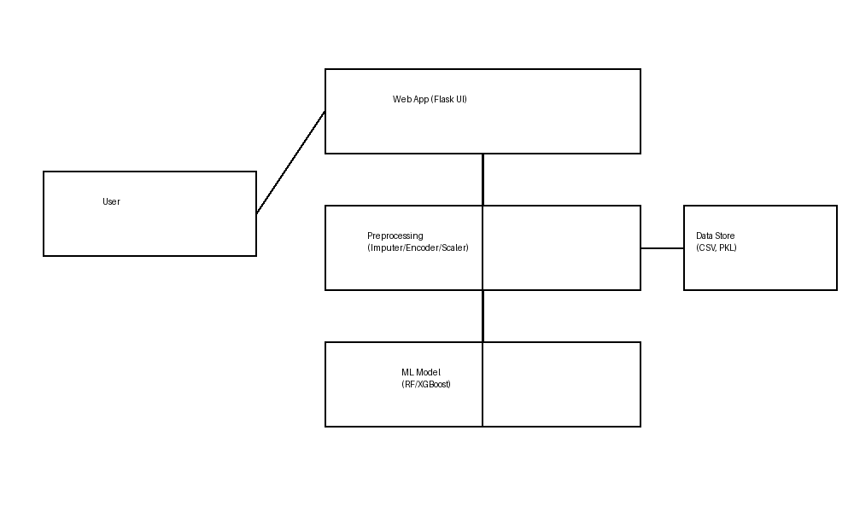

User Stories
User Type | Epic | User Story No. | User Story / Task | Acceptance Criteria | Priority | Release
Farmer (Web User) | Prediction | USN-1 | As a user, I can enter weather inputs and get rainfall prediction. | Prediction is displayed with rain/no-rain result. | High | Sprint-1
Farmer (Web User) | EDA | USN-2 | As a user, I can view rainfall trends and seasonal charts. | Charts load correctly for selected region. | Medium | Sprint-1
Agri Officer | Insights | USN-3 | As an officer, I can view regional rainfall summaries. | Summaries show monthly/seasonal aggregates. | High | Sprint-2
Admin | Model Ops | USN-4 | As an admin, I can update the trained model artifacts. | New model loads without breaking predictions. | Medium | Sprint-3
Any User | UX | USN-5 | As a user, I can see clear result pages for rain/no-rain. | Result page renders with message and visuals. | High | Sprint-1

